TWEETING SECURITY SYSTEM
Abhishek kumar singh, Suyash sowmya, Ashwij S
Designation, Cse,M.S.R.I.T,Bangalore, India
Designation, Cse,M.S.R.I.T,Bangalore, India
Designation, Cse,M.S.R.I.T,Bangalore, India

Abstract:
In the present age Internet of things (IOT) has enterned a golden era of rapid growth. The Internet of things is a concept that aims to extend the benefits of the regular Internet—constant connectivity, remote control ability, data sharing, and so on—to goods in the physical world. Everyday things are getting connected with the internet. This concept can be used tomanage the security concerned issues in a cost effective way. In ths paper work a system is being developed to connect any door with the internet, so that the access control system can be controlled from any where in the world. In a case that one is not at home and a vistor is at his door steps then the authorized person will be notified about the visitor via twitter and the person can see the visitor from the web through the camera from any where and the system will take a picture of the visitor and keep a record by sending an attachment through E-mail or tweet in twitter. If the authorized person wants to give a message the visitor it can be sent easily through the internet and it will appear in a screen on the front face of the door. The door lock can be controlled through the internet. With the help of this system an evidence of the visitor can be kept as a record if any emergency case or situtaion occurs.

Keywords:
Internet of Things (IOT), Raspberri Pi, Wireless Door Control, Security Measures,Wi-Fi module, PIR Sensor, Human detection

Introduction

In this modern world crime has become ultra modern too! In this current time a lot of incident occurs like robbery, stealing unwanted entrance happens abruptly. So the security does matters in this daily life. People always remain busy in their day to day work also wants to ensure their safety of their beloved things. Sometimes they forget to look after their necessary things like keys, wallet, credit cards etc. Without these, they are unable to access their home or any place they want. To prevent such incidents many scholars came into action and tried to pro-hibit them. Like YanboZhao ; ZhaohuiYe introduced “A GSM/GPRS based wireless home security system but the system is not cost effective as the GSM/GPRS charges a fixed amount from each sms/call. Face recognition based on auto-switching magnetic door lock system using microcontroller” but face recognition means com-plex algorithms and sometimes the system may be unable to detect the visitors identification correctly and keeps a computer chip busy for longer time.The user can see from anywhere in this world that who is at his door steps. The system keeps a picture of the visitor as evidence that would be needed if any unwanted situation occurs like stealing, robbery etc. The user can control the door with a single command through the internet by mobile, pc, tablets etc. This system can also be used for industrial automation wirelessly. Also for any kind of accident like fire, or stolen keys the door can be opened by a single and simple command. As a result the security is con-firmed also the mental peace.

Design

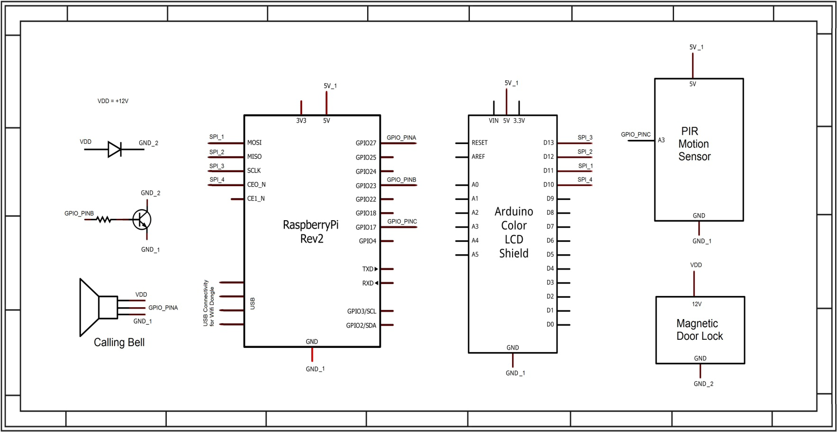
Implementation
Fswebcam is used to take the webcam snapshots by the Wi-Fi camera. Also this Wi-Fi camera is accessible from anywhere for a live view of the visitor.
sudo apt-get install fswebcam
Here is the interrupt portion. If interrupt from PIR sensor happens then the cam is commanded to take snapshot. sudo apt-get install fswebcam
if (GPIO.input(buttonPin)):
#this is the script that that will called as(root) os.system("fswebcam -r 960x720 -d/dev/video0/home/pi/webcam.jpg") os.system("python /home/pi/sendnotify.py")
USERNAME = "internetofdoor@gmail.com" PASSWORD = "awsedrft123" server = smtplib.SMTP('smtp.gmail.com:587') server.ehlo_or_helo_if_needed() server.starttls() server.ehlo_or_helo_if_needed() server.login(USERNAME,PASSWORD)
Testing and Comparison

this project with a minicomputer raspberry pi different input and output is interfaced. In input section there is calling bell, PIR sensor & wireless camera. In processing section a minicomputer raspberry pi is used. Raspberry pi is equipped with wifi dongle. And on the output terminal there are Lcd, magnetic door lock, emailing & tweeting services. A calling bell is placed on door so that if someone visits the user the person will press the bell and the bell will generate a signal to raspberry pi indicating presence of a person. There is also another way of sensing human and that is passive infra red human motion detection sensor. If any thief tries to break into the house PIR sensor will identify the motion of that human and will transmit an alarm to raspberry pi. Most im-portant input device is the wireless camera. It is used to see video stream and also whenever a person comes it takes a snapshot of that person and transmit it to raspberry pi. Raspberry pi process these inputs like whenever it gets a calling bell as input it trans-mits a signal to wireless camera to capture an image of the visitor. Within the time it receives the picture it generate a Tweet alerting the user that someone has arrived infront of door. After receiving the image raspberry pi sends a mail to user attaching the picture. User can control the magnetic lock through twiter. If user wants to permit the visitor access he can turn on the lock and if he wants to reject access for any reason user can show the reason to LCD tweeting a text for visitor
Results
The system needs its own username and password so that it can access to the account and generate a mail automatically. The email address and password of the system is given bel-low.
USERNAME = "internetofdoor@gmail.com" PASSWORD = "awsedrft123"
server= smtplib.SMTP('smtp.gmail.com:587') server.ehlo_or_helo_if_needed() server.starttls() server.ehlo_or_helo_if_needed() server.login(USERNAME,PASSWORD) server.sendmail(USERNAME,to,msg.as_
string())
server.quit()
After connecting to the server the server needs the email address of the user. The users email address is given bellow. sendMail( ["mdnasime@gmail.com"], "Door Bell Alert! Visitor Snap-shot", "Someone is at your door and ringing your door bell. Please See the Attached picture.",
["/home/pi/ Visitor at your door.jpg "] )
Scope and Future work

Internet of households where we can attach otherdevices of house with internet.
Industrial automation and control through internet.
Automated fire exit systems can be build
Improvement in the security issues in highly re-stricted areas

Conclusion
The system can be used in several places like banks, hospitals, labs and other sophisticated automated systems, which dramatically reduce the hazard of unauthorized entry. Evidence can be given to the security department if any robbery issue occurs. But the system needs to be monitor always that the internet bills are paid in due time to keep connected with own home.
Reference
[1] Jae Hoon Lee ; Yong-Shik Kim ; Bong Keun Kim ; Ohba,K. ;Kawata,H. ; Ohya,A. ; Yuta,S. “Security Door System Using Human Tracking Method with Laser Range Finders” , IEEE- In-ternational Conference on Mechatronics and Automation 2007. ICMA 2007.
[2] YanboZhao ; ZhaohuiYe “A low cost GSM/GPRS based wireless home security system” IEEE Transactions on Consumer Electronics, (Vo-lume:54 , Issue: 2 )
[3] Hassan,H. ; Bakar,R.A. ; Mokhtar,A.T.F. ” “Face recognition based on auto-switching magnetic door lock system using microcontroller” IEEE-International Conference on System Engineering and Technology (ICSET), 2012
[4] Assaf, M.H. ; Mootoo, R. ; Das, S.R. ; Petriu, E.M. ; Groza, V. ;Biswas, S. “Sensor based home automation and security system” Instrumenta-tion and Measurement Technology Conference (I2MTC), 2012 IEEE In-ternational
[5] Ibrahim, R. ; Zin, Z.M. “Study of automated face recognition system for office door access control application” IEEE 3rd International Confe-rence on Communication Software and Networks (ICCSN), 2011
[6] information about PIR sensor http://www.glolab.com/pirparts/infrared.html
and information of PIR and lens http://www.ladyada.net/learn/sensors/pir.html

